Young adults’ goal perceptions prior to and during COVID-19

Report prepared by Denise de Ridder, Jeroen Benjamins, Jantina Brummelman, Marleen Gillebaart, Floor Kroese & Jan Fekke Ybema

Ten Years Up

July 2022

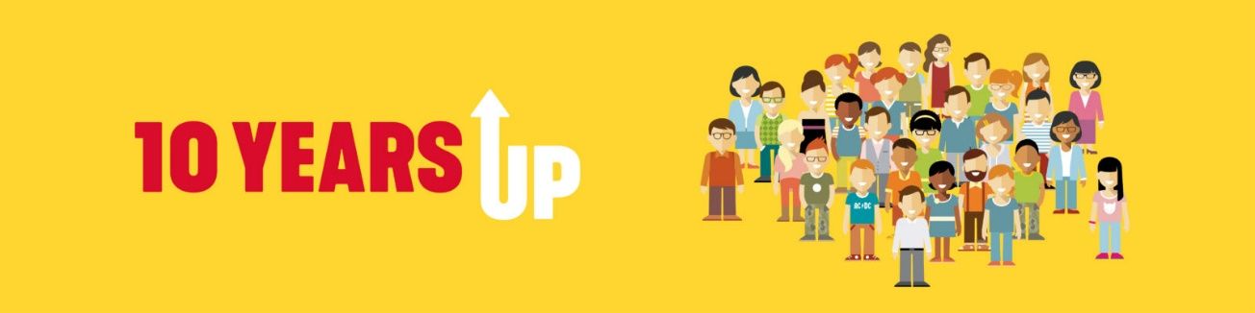
Abstract
Concordance between importance and attainability of personal goals is considered a prerequisite for wellbeing. The COVID-19 pandemic may impose a threat to attainment of important goals. In the present research we examined adolescents’ (N = 147) perceptions of goal importance and attainability prior to (retrospective) and during COVID-19. We found that as compared to the situation before COVID-19, adolescents regarded their goals as less attainable while they continued to find them equally important. Participants who were optimistic about the future reported higher concordance whereas those who adhered more strictly to COVID-19 measures reported lower concordance. In order to prevent nihilism in young people, public health policy should consider creating better conditions for the realization of important goals during COVID-19.

Introduction

Motivational theories assert that the degree to which individuals succeed in accomplishing their personal goals is related to wellbeing (Brunstein, 1993; Emmons & King, 1988). Personal goals, regardless of whether they are called ‘life tasks’ (Cantor et al., 1991), ‘personal projects’ (Little, 1989), or ‘personal strivings’ (Emmons, 1986), constitute cognitively elaborated representations of a wished-for condition and as such are a source of purpose and meaning in life (Austin & Vancouver, 1996; Carver & Scheier, 1998; Emmons, 1986). High goal commitment generally leads to increased effort to realize a goal as does a strong belief in attainability which is associated with confidence in one’s ability to do what is necessary to achieve a goal. Doubt about the feasibility or importance of goals, on the other hand, may create considerable distress, such as when changed circumstances threaten goal attainment (Brunstein, 1993; Kuijer & De Ridder, 2003).

The 2020 Covid-19 pandemic may impose such a goal threat to the extent that measures to curb the spreading of the new virus impact on opportunities to achieve one’s goal. Physical distancing and limitations on group gatherings, for example, may lead to fewer possibilities to meet with friends or engage in leisure activities – and thus hinder social goals. The pandemic may also interfere with career plans because of economic repercussions and expected unemployment for those entering the labor market (Patterson, 2020). Moreover, on top of these realistic threats, COVID-19 may also impose symbolic threats because distancing and related measures weaken one’s sense of belonging to neighborhoods, schools, work places, or other kinds of communities (Kachanoff, Bigman, Kapsaskis, & Gray, 2020). Both kinds of threats, realistic and symbolic, especially apply to young people because the pandemic coincides with a life phase in which they make important decisions about school, work, peers, and romantic relationships. In particular, the changed circumstances because of COVID-19 may affect perceptions of importance and attainability of their personal goals. As such, the consequences of the COVID-19 pandemic for young people go well beyond the immediate health risk of falling ill. In the current study we examine how young people view the importance and attainability of their goals as compared to the situation before the onset of the pandemic.
Goals, discrepancies, and wellbeing
The existing body of psychological goal research has primarily focused on how people deal with goals that remains fixed during a single period, leaving unaddressed the important question of how goals are updated over time (Austin & Vancouver, 1996; Carver & Scheier, 1998; Locke & Latham, 1990). As a result, not much is known about when and how goals are revised (De Ridder & Kuijer, 2006; Wang & Mukhopadhyay, 2011). Nevertheless, people may recalibrate their original goal depending on the opportunities for goal achievement (Carver & Scheier, 2000). Sometimes the shift is upward to accommodate a higher level of aspiration, such as when someone who achieves a goal of running five miles in an hour may then aim higher and strive for running six miles instead. The shift may also be downward when a goal is beyond reach and requires a less demanding target, such as when someone finds it impossible to run for an hour at a time and therefore downgrades their goal to 45 minutes. Downward goal revision has proven to be a challenging task, even when people experience slower-than-expected progress to goals or no progress at all. Theoretically speaking, people may respond in two different ways when they are confronted with difficulties to accomplish their goals. They may either make increased efforts to attain a goal (making the goal more attainable, labelled as ‘assimilative persistence’) or they may neutralize goal discrepancies by downgrading aspirations (making the goal less important, referred to as ‘accommodative flexibility’; Brandtstädter & Renner, 1990; Rothermund & Brandstädter, 2003) Generally speaking, most people are not inclined to lower their initial commitment to goals and prefer assimilation over accommodation when faced with obstacles in goal pursuit (Wrosch, Scheier, Miller, Schulz, & Carver, 2003). A study by Emmons, Colby, & Kaiser (1998), for example, found that in response to a major life event, people expressed more commitment to goals they regarded important prior to the event while at the same time having more doubts about their attainability and as such experienced considerable frustration because of this discrepancy. Reducing the importance of a goal or other less rigorous forms of downgrading aspirations (e.g., positive reappraisal) are thus hard to realize when a goal occupies a central place in one’s goal hierarchy, even though several studies have demonstrated that accommodation eventually allows for a reorientation to other, more promising goals (Wrosch et al., 2003).

Taken together, it has been found that in times of adversity many people stick to the goals they find important even when they acknowledge that it may be harder to achieve them. The lack of concordance between importance and attainability is a source of distress because people may maintain striving for goals in the expectation that goal progress will be low. In view of this, the present study examines how the COVID-19 pandemic affects young people’s goals, in particular whether and how they adjust their evaluations of goal importance and attainability by comparing their (retrospective) initial ratings before the COVID-19 pandemic with ratings a few months after the outbreak. Specifically, we will address the following hypotheses. First, prior to COVID-19 we expect evaluations of goal importance and attainability to be concordant, such that important goals are considered to be more attainable than less important goals (or vice versa, that goals within reach gradually become important). Theoretically speaking, equally low ratings of importance and attainability also constitute concordance, but in case a goal is regarded both relatively unimportant and unattainable the idea of a goal as a desired end state does no longer apply (De Ridder & Kuijer, 2006). Second, we expect a significant decrease in the overall attainability of goals in times of COVID-19 as compared to prior to the outbreak. Third, we expect that concordance between importance and attainability of goal evaluations will be lower in times of COVID-19 than before. Next to these hypotheses, we will address a number of exploratory questions regarding which people will most likely adjust their evaluations of importance and attainability. Specifically, we will examine whether lower concordance of importance and attainability ratings is more prominent amongst young people who more strictly adhere to the distancing rules with potential repercussions on opportunities for working on one’s goals. We will also address the question whether concordance may be higher in adolescents who are optimistic about the future in times of COVID-19 as high expectancies may impact their perceptions of possibilities for realizing their goals; the same reasoning applies to perceptions of being connected to one’s future self (Hershfield, 2011). Finally, we will examine potential differences regarding gender, age, and education level in ratings of goal importance and attainability.

Method
Participants
A convenience sample of young adults (16-25 years) was recruited via social media in the early stages of the pandemic (April 2020). Of the 379 participants who read the introduction on the online survey, 359 agreed to informed consent. A total number of 147 participants completed the entire survey. Two participants were removed because they had virtually no variation in either the importance or the attainability of the goals, leaving 145 participants (response rate 38%) with in total 9569 ratings of goals (there was one occasional missing). Mean age of these 145 participants (75% female) was 20.5 years (SD = 2.8). The majority of the participants followed or had completed higher level education, including applied sciences (21%) and university (44%). The remaining participants (35%) were following or had completed secondary education or lower level professional education.

Measures
Participants filled out an abbreviated version (i.e., the goal setting part without goal striving questions) of the Goal Setting and Striving Inventory (GSSI; Gillebaart, Brummelman, & De Ridder, 2021) twice on one specific occasion: once as it applied to them before COVID-19 retrospectively viewed from their current situation and once as it applied to their current situation (May 2020, approximately two months after the COVID-19 outbreak in the Netherlands). The GSSI lists a number of 33 goals that were derived from expert consultation and a series of pilot studies in the target population of young adults. The GSSI names a wide variety of goals relevant to young people, including both social (e.g., ‘meet with my friends more often’) and health (e.g., ‘reduce my alcohol intake’) goals, as well as wellbeing (e.g., ‘experience less stress’) and career (e.g., ‘find a job’) goals (see Table 1 for the full list). In accordance with how young adults frame their strivings, the list includes goals both on a concrete and a more abstract level that are either more immediate or longer term. All 33 goals were rated on a 0-100 Visual Analogue Scale both regarding importance and attainability. In the present study, we were not interested in specific goal ratings as such but rather used the GSSI to get an overall impression of shifts in importance and attainability resulting from adversity due to COVID-19. For that reason, participants were asked to complete the GSSI prior (in hindsight) and during COVID-19, interspersed with questions on perceptions of COVID-19 measures to encourage vivid imagination of the new situation and its potential repercussions on goal progress. Specifically, they filled out three questions about adherence to COVID-19 measures (e.g., ‘I stay home as much as possible’, ‘I keep distance to others when I am outside my home’, and ‘I adjust my behavior so as to reduce the impact of the pandemic’) on a 7-point scale ranging from 1 (not at all) to 7 (completely). Cronbach’s alpha of the three items was good (.75) and an overall adherence score was computed. Participants also filled out two questions about COVID-19 specific optimism (‘I am optimistic about the future’ and ‘During the COVID-19 pandemic I am able to attain my goals’), both on a 7-point scale. These two items correlated substantially (r = .47) and were computed into an overall optimism score. Finally, participants reported the extent to which they felt connected to their future selves (Hershfield, 2011), again on a 7 point scale.
Analyses
Hierarchical multilevel regressions with overall goal attainability (during COVID-19) as the dependent variable was conducted in SPSS 23 with the Linear Mixed Models program, using Maximum Likelihood estimation. In line with recommendations of Enders and Tofighi (2007), person level predictors were grand mean centered (GMC, i.e., the overall mean was subtracted), whereas within person level predictors were person mean centered (PMC, i.e., the individual’s own average score was subtracted), and dummy-coded dichotomous variables were used. The data were analyzed with goals (level 1) nested under participants (level 2). In the multilevel regressions of goal attainability, the average importance of these goals (person level) and two within-person level predictors were entered: the relative importance of the specific goal and the dummy variable ‘timing’, which indicated whether the goal was rated retrospectively for the time prior to the COVID-19 pandemic (timing = 0) or during the COVID-19 outbreak (timing = 1), and the interaction between the relative importance and timing. Additional main effects and interactions with the relative importance and timing of demographic variables gender (0 = female; 1 = male), education (0 = lower or medium level, 1 = higher level education), and age (grand mean centered) were also tested. There was a substantial number of missing values for age (22.8% of the participants). These missing values were replaced by the mean value of age, and an additional dummy variable was added to control for these missing values (0 = age is valid; 1 = age is missing) (Cohen & Cohen, 1983).
Both the importance and the attainability of goals were rated on a scale from 0 to 100. A substantial number of goals were rated as irrelevant, with importance rated as 0 (22.4% of all ratings). When importance was rated as 0, attainability was also often rated as 0 (13.1% of all ratings). This pattern may confound the results and increase the predicted concordance between importance and attainability. We therefore repeated all analyses without irrelevant goals (importance = 0) to examine the robustness of the results. The results of these sensitivity analyses were similar to those presented below.

Results
Ratings of individual goals
Descriptive statistics of the importance and attainability of individual goals, and the results of Generalized Linear Modelling (GLM) to determine the difference in ratings before and during COVID-19 are shown in Table 1.

Table 1 Importance and attainability ratings of goals prior to and during COVID-19 (N = 145)
Goals | Importance before (retrospective)  M (SD) | Importance during the pandemic  M (SD) | Attainability before  (retrospective)  M (SD) | Attainability during the pandemic  M (SD) | GLM Importance  F (p) | GLM Attainability  F (p)
Saving money for a long holiday | 56.53 (36.55) | 53.85 (38.17) | 56.61 (33.89) | 37.26 (34.46) | 1.76 (.19) | 33.39 (<.001)***
Go to bed in time more often | 59.80 (31.00) | 58.28 (31.77) | 56.01 (28.50) | 56.99 (33.68) | 0.35 (.56) | 0.11 (.74)
Less screen time | 48.32 (31.76) | 53.25 (33.60) | 53.09 (27.20) | 29.56 (28.81) | 5.96 (.016)* | 70.15 (<.001)***
Exercise more often | 70.11 (29.11) | 73.94 (27.56) | 62.77 (28.77) | 55.07 (34.39) | 3.01 (.085) | 4.75 (.031)*
Finish my homework in time | 47.16 (36.19) | 48.29 (38.73) | 56.90 (32.95) | 43.94 (35.75) | 0.24 (.63) | 19.77 (<.001)***
Get to school/work in time | 31.72 (35.68) | 22.53 (34.42) | 60.06 (39.57) | 33.83 (41.36) | 9.39 (.003)** | 53.20 (<.001)***
Quit smoking | 7.17 (21.53) | 7.18 (21.45) | 39.52 (45.59) | 34.86 (44.22) | 0.00 (.99) | 2.46 (.12)
Tidy up my room more often | 49.47 (28.61) | 61.40 (31.77) | 61.12 (28.21) | 72.66 (28.01) | 21.01 (<.001)*** | 19.14 (<.001)***
Lose weight | 39.86 (37.73) | 48.82 (38.25) | 51.06 (32.90) | 46.71 (33.86) | 19.11 (<.001)*** | 2.63 (.11)
Being more kind to other people | 59.06 (31.86) | 69.32 (27.36) | 66.48 (27.87) | 60.99 (30.83) | 27.33 (<.001)*** | 3.86 (.051)
Reduce my alcohol intake | 23.01 (28.94) | 28.01 (33.07) | 52.38 (38.38) | 55.06 (39.77) | 6.59 (.011)* | 0.73 (.40)
Reduce single-use plastic | 51.99 (32.53) | 50.28 (33.49) | 57.58 (24.57) | 51.67 (31.19) | 0.96 (.33) | 6.08 (.015)*
Reduce meat consumption | 51.90 (35.75) | 51.13 (36.66) | 67.08 (31.74) | 57.28 (34.57) | 0.22 (.64) | 16.57 (<.001)***
Finish my education | 77.37 (37.00) | 73.86 (37.61) | 72.86 (33.20) | 56.10 (36.45) | 3.46 (.065) | 30.86 (<.001)***
Walk or cycle more often | 53.22 (33.27) | 66.01 (32.51) | 68.46 (31.49) | 61.53 (34.84) | 22.65 (<.001)*** | 3.67 (.057)
Earn my own money | 68.70 (33.26) | 70.84 (31.66) | 65.73 (32.30) | 39.26 (35.43) | 1.40 (.24) | 62.34 (<.001)***
Increase fruit and vegetable consumption | 62.23 (29.50) | 66.91 (29.96) | 71.74 (25.34) | 72.33 (26.26) | 7.39 (.007)** | 0.065 (.80)
Pay off financial debts | 21.41 (33.59) | 21.67 (33.59) | 34.39 (39.00) | 26.77 (36.59) | 0.029 (.87) | 6.63 (.011)*
Reduce consumption of energy drinks | 5.20 (16.75) | 5.47 (18.11) | 47.82 (47.28) | 39.50 (46.00) | 0.062 (.80) | 7.39 (.007)**
Decide about next steps of my education | 49.57 (42.67) | 46.78 (42.60) | 54.07 (37.87) | 40.00 (36.86) | 1.86 (.18) | 19.50 (<.001)***
Have a better relationship with my parents | 45.79 (33.02) | 57.34 (34.86) | 58.78 (31.92) | 60.08 (33.69) | 31.03 (<.001)*** | 0.30 (.59)
Live on my own | 34.38 (40.88) | 26.14 (38.21) | 42.24 (41.26) | 26.86 (35.61) | 9.50 (.002)** | 27.32 (<.001)***
Learn to play a music instrument | 25.78 (31.92) | 26.51 (34.27) | 35.53 (34.26) | 35.14 (35.43) | 0.24 (.62) | 0.023 (.88)
Becoming successful | 72.58 (27.15) | 68.54 (31.43) | 65.14 (23.45) | 41.75 (28.41) | 4.60 (.034)* | 79.80 (<.001)***
Meet with my friends more often | 70.29 (26.40) | 74.98 (29.13) | 60.79 (27.80) | 21.08 (27.34) | 3.97 (.048)* | 166.32 (<.001)***
Improving my sports performance | 51.41 (37.45) | 50.10 (37.65) | 52.43 (34.00) | 33.39 (33.92) | 0.35 (.55) | 33.94 (<.001)***
Earn a lot of money | 55.30 (30.74) | 57.74 (34.69) | 50.82 (26.17) | 34.61 (31.56) | 1.36 (.25) | 28.20 (<.001)***
Enjoy life more | 81.10 (20.59) | 82.08 (19.10) | 66.80 (24.81) | 45.13 (26.77) | 0.34 (.56) | 58.15 (<.001)***
Get my driver’s licence | 33.68 (42.83) | 30.31 (42.54) | 44.49 (42.68) | 19.17 (33.42) | 4.09 (.045)* | 53.66 (<.001)***
Learn another language | 40.08 (34.03) | 39.27 (35.98) | 44.90 (29.37) | 46.49 (34.68) | 0.17 (.68) | 0.29 (.59)
Experience less stress | 76.55 (23.55) | 76.63 (23.46) | 52.88 (24.48) | 52.62 (32.56) | 0.002 (.96) | 0.007 (.94)
Become more self-confident | 65.01 (31.42) | 62.72 (33.57) | 58.45 (25.75) | 45.08 (28.00) | 1.66 (.20) | 24.93 (<.001)***
Find a job | 52.33 (40.14) | 50.88 (41.95) | 59.96 (33.76) | 28.62 (30.79) | 0.24 (.63) | 98.67 (<.001)***
Average all goals | 49.64 (11.98) | 50.94 (12.83) | 56.03 (13.88) | 44.29 (15.75) | 6.16 (.014)* | 144.94 (<.001)***

Multilevel analyses for the concordance between importance and attainability
Table 2 shows the results of the multilevel analyses of attainability. Model 1 shows that the intraclass coefficient (ICC) = .13, which means that 13% of the variation in the attainability of goals reflects differences between participants (the remaining variance of 87% is thus due to within participant variation prior to and during COVID-19). In Model 2, the average (person level) importance of goals, the importance of the specific goal (within person level), and whether the rating of the goal concerned the time prior to or during COVID-19 were entered. The model shows that goals that were considered as more important, both on average and for the specific goal in question, were also considered as more attainable. This confirms our first hypothesis that concordance between importance and attainability of goals was present both at person level (persons who on average rated goals as more important also considered goals as more attainable) and at goal level (an individual who rated a specific goal as important was also more likely to consider that goal as attainable), reflecting concordance. Moreover, as predicted in our second hypothesis, during COVID-19 goals were considered less attainable than before the onset of COVID-19. The average decline in attainability of goals was 12 points on a scale from 0 to 100. In Model 3 the interaction between the (goal level) attainability and timing was entered. This interaction contributed to the regression of attainability of goals. Figure 1 shows this interaction. As can be seen, in line with the third hypothesis, the positive relationship between importance and attainability of goals (i.e., concordance) was weaker during COVID-19 than before COVID-19. For relatively unimportant goals (M – 1SD) the decline in attainability of the goals was 8.5 points on a scale from 0 to 100, whereas for relatively important goals (M + 1SD) the decline in attainability was almost twice as large (15.9 points).

Table 2 Multilevel regression of goal attainability
predictors | Model 1 |  | Model 2 |  | Model 3 |  | Model 4 |  | Model 5
Intercept | 50.16 | *** | 56.25 | *** | 56.28 | *** | 53.81 | *** | 53.86 | ***
Average Importance (Person Level) |  |  | 0.43 | *** | 0.43 | *** | 0.47 | *** | 0.47 | ***
Importance of Goal (Goal Level) |  |  | 0.33 | *** | 0.39 | *** | 0.39 | *** | 0.37 | ***
Timing (0=Before; 1=During COVID-19) |  |  | -12.18 | *** | -12.18 | *** | -12.18 | *** | -12.27 | ***
Importance x Timing |  |  |  |  | -0.10 | *** | -0.10 | *** | -0.10 | ***
Gender (0 = Female; 1 = Male) |  |  |  |  |  |  | 8.74 | *** | 9.46 | ***
Age |  |  |  |  |  |  | 0.46 |  | -0.02
Age missing |  |  |  |  |  |  | -0.64 |  | -0.64
Education |  |  |  |  |  |  | 0.57 |  | 0.21
Gender x Importance |  |  |  |  |  |  |  |  | -0.14 | ***
Gender x Timing |  |  |  |  |  |  |  |  | -1.44
Age x Importance |  |  |  |  |  |  |  |  | -0.01 | **
Age x Timing |  |  |  |  |  |  |  |  | 0.97 | **
Education x Importance |  |  |  |  |  |  |  |  | 0.09 | ***
Education x Timing |  |  |  |  |  |  |  |  | 0.73
Fit (-2 log L) | 94,706.77 | *** | 92,986.81 | *** | 92,952.40 | *** | 92,937.46 | *** | 92,833.19 | ***
Δ fit |  |  | 1,719.96 | *** | 34.41 | *** | 14.94 | ** | 104.27 | ***
df |  |  | 3 |  | 1 |  | 4 |  | 6
Variance
random intercept (person level) | 164.41 | *** | 144.29 | *** | 144.48 | *** | 128.95 | *** | 129.11 | ***
residual (goal level) | 1,122.43 | *** | 937.37 | *** | 933.94 | *** | 933.94 | *** | 923.66 | ***
ICC | 0.13
explained variance |  |  | 16% |  | 16% |  | 17% |  | 18%
Note: * p < .05; * p < .01; * p < .001

Figure 1 Concordance between goal importance and attainability before and during COVID-19

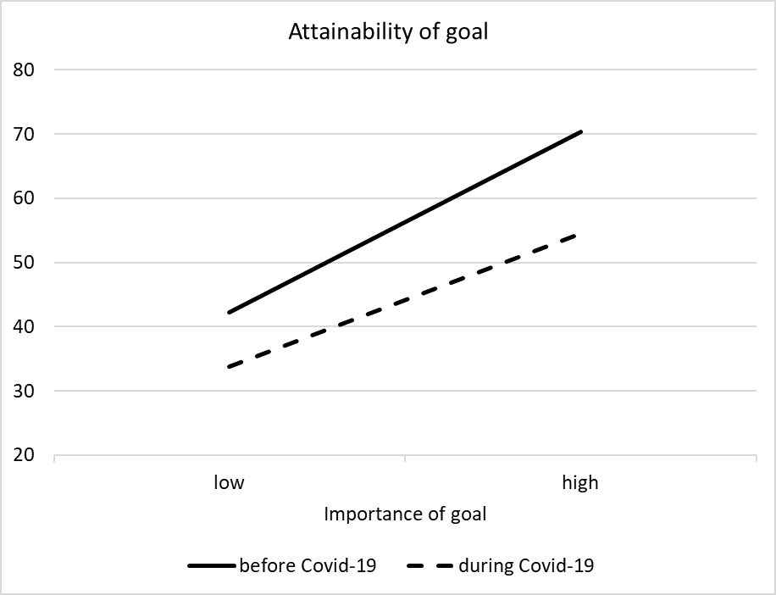

The role of gender, age, and education
In Model 4 (shown in Table 2) the main effects of gender, age (including the dummy for missing values), and education were entered. This model shows that only gender had a main effect. Young men considered the attainability of their goals as higher than young women. Finally, in Model 5 (also shown in Table 2) the two-way interactions of demographic variables with the importance of the goals (goal level) and with timing were added. This model shows that for young men the concordance between importance and attainability was weaker than for young women. There was a significant interaction of age with both importance and timing of goals. For older participants, the concordance between importance and attainability was somewhat weaker than for younger participants, and the impact of timing on the attainability of goals was weaker for older than younger participants. In an additional analysis, the interactions with the dummy variable indicating missing values for age were added to the regression. These interactions did not reach significance, nor did they change the results. Finally, concordance between importance and attainability of goals was stronger for higher educated participants as compared to participants with lower education levels. An additional model with three-way interactions between each demographic variable, goal importance and timing did not add significantly to the regression.

The role of adherence, optimism, and connection to future self
Participants reported to adhere to COVID-19 measures to a relatively strong degree (M = 5.82; SD = 1.03) and were overall moderately optimistic about the future during COVID-19 (M = 4.21; SD = 1.23). They felt somewhat connected to their future self (M = 3.89; SD = 1.61), with relatively large differences between participants. Table 3 shows the results of optimism, adherence to COVID-19 measures, and future self-connection being added to the multilevel regression. In order to reduce complexity, only the main effects of demographic variables (Table 2, Model 4) were kept in the regression. In Model 6 the main effects of optimism, adherence, and future self-connection were added, showing that young people with a more optimistic outlook on life during COVID-19 regarded the attainability of the goals as higher. In Model 7 the interactions with goal importance and timing were added, showing that participants with a higher future self-connection regarded important goals as more attainable, confirming the notion that these participants report a stronger concordance between importance and attainability of goals. Moreover, the impact of COVID-19 on attainability was weaker for optimistic participants and for participants with a higher future self-connection. In contrast, participants who more strictly adhered to COVID-19 measures reported lower goal attainability. Finally, Model 8 with three-way interactions shows that for optimistic participants (M + 1SD) the concordance between goal importance and attainability remained intact in times of COVID-19, whereas for participants low in optimism (M – 1SD), concordance reduced. For optimistic participants, attainability of both important (-9.7) and unimportant goals (-8.1) was somewhat reduced during COVID-19, but for participants low in optimism, this reduction was much more prominent for important goals (-21.8) than for unimportant goals (-9.1). This is shown in Figure 2.

Table 3 Multilevel regression of goal attainability including optimism, adherence, and future self-connection.
predictors | Model 4 |  | Model 6 |  | Model 7 |  | Model 8
Intercept | 53.81 | *** | 55.01 | *** | 55.00 | *** | 55.02 | ***
Average Importance (Person Level) | 0.47 | *** | 0.52 | *** | 0.52 | *** | 0.52 | ***
Importance of Goal (Goal Level) | 0.39 | *** | 0.39 | *** | 0.39 | *** | 0.39 | ***
Timing (0=Before; 1=During COVID-19) | -12.18 | *** | -12.18 | *** | -12.15 | *** | -12.15 | ***
Importance x Timing | -0.10 | *** | -0.10 | *** | -0.10 | *** | -0.10 | ***
Gender (0 = Female; 1 = Male) | 8.74 | *** | 8.44 | *** | 8.44 | *** | 8.47 | ***
Age | 0.46 |  | 0.53 |  | 0.53 |  | 0.54
Age missing | -0.64 |  | 0.18 |  | 0.18 |  | 0.21
Education | 0.57 |  | -1.44 |  | -1.44 |  | -1.46
Optimism |  |  | 3.42 | *** | 2.07 | * | 2.04 | *
Adherence |  |  | -1.07 |  | -0.32 |  | -0.34
Future self-Connection |  |  | 0.45 |  | 0.00 |  | 0.00
Optimism x Importance |  |  |  |  | 0.01 |  | -0.02
Optimism x Timing |  |  |  |  | 2.68 | *** | 2.68 | ***
Adherence x Importance |  |  |  |  | 0.00 |  | -0.01
Adherence x Timing |  |  |  |  | -1.49 | * | -1.49 | *
Connection x Importance |  |  |  |  | 0.02 | ** | 0.01
Connection x Timing |  |  |  |  | 0.90 | * | 0.90 | *
Optimism x Importance x Timing |  |  |  |  |  |  | 0.06 | ***
Adherence x Importance x Timing |  |  |  |  |  |  | 0.02
Connection x Importance x Timing |  |  |  |  |  |  | 0.01
Fit (-2 log L) | 92,937.46 | *** | 92,913.05 | *** | 92,832.83 | *** | 92,807.58 | ***
Δ fit | 14.94 | ** | 24.41 | *** | 80.22 | *** | 25.25 | ***
df | 4 |  | 3 |  | 6 |  | 3
Variance
random intercept (person level) | 128.95 | *** | 106.78 | *** | 106.90 | *** | 107.03 | ***
residual (goal level) | 933.94 | *** | 933.94 | *** | 926.02 | *** | 923.53 | ***
ICC
explained variance | 17% |  | 19% |  | 20% |  | 20%
Note: * p < .05; * p < .01; * p < .001

Figure 2 Concordance between goal importance and attainability before and during COVID-19 for individuals high and low in optimism

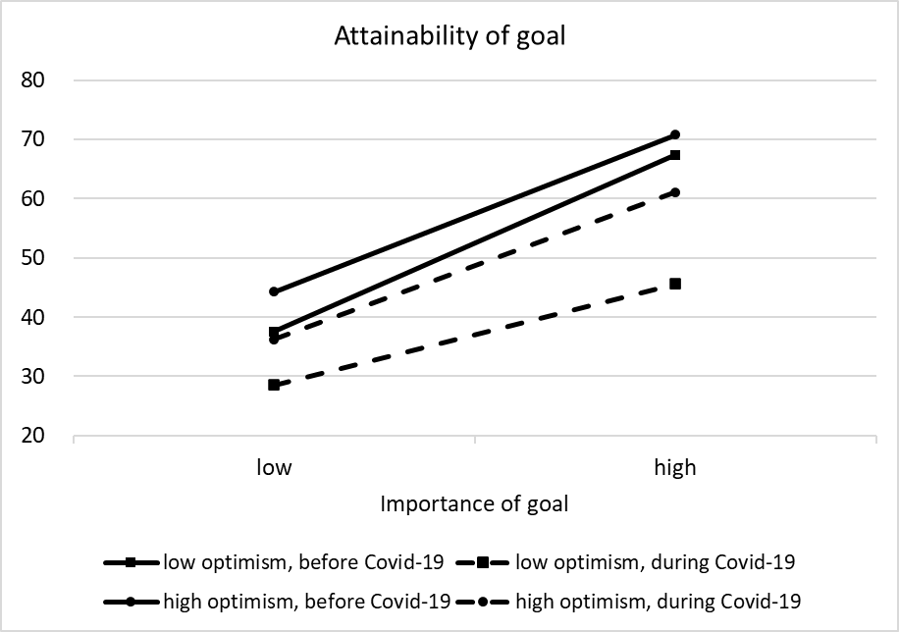

Discussion

The present COVID-19 pandemic holds immense consequences for how people lead their lives in many respects. On top of the health risk of getting infected with the virus, the pandemic also bears social and economic implications for large parts of the population, including whether they are able to realize their ambitions. This especially applies to young adults who, in spite of a lower risk of getting infected, are confronted with challenges at a moment in their lives when they make plans for the future in many important areas, such as school, work, (romantic) relationships and any other kind of aspirations. In the present study we examined how the pandemic affects perceptions of importance and attainability of young people’s goals. In line with our predictions, we found that as compared to the situation before COVID-19 (in retrospect) young adults regarded their goals as less attainable while they continued to find them equally important. This effect was even more pronounced for goals that were regarded as the most important ones. This observation is in line with previous studies showing that in times of adversity people continue to stick to their goals even when they experience fewer possibilities to realize them (De Ridder & Kuijer, 2006; Emmons et al., 1998; Kuijer & De Ridder, 2003), leading to elevated levels of distress and eventually lower wellbeing (Carver & Scheier, 1998). We also found that perceptions of lower attainability were more often present in women, whereas the discrepancy between importance and attainability was higher in men, older participants, and participants with a lower education level. Participants who were optimistic about the future reported a higher importance-attainability concordance whereas those who adhered more strictly to measures reported lower attainability of goals during COVID-19. The latter implies that adherence, possibly relating to motivation to protect other people from falling ill, comes with the cost of lower chances to realize one’s ambitions. From the goals that were examined in the present study, it may seem that some of them relate to trivial pursuits such as when it concerns ‘tidy up my room more often’ or ‘saving money for a long holiday’. Nevertheless, these goals were mentioned as important tasks by young adults when constructing the GSSI. Moreover, even seemingly trivial goals may have a large impact on one’s life similar to the impact of daily hassles on quality of life as compared to major life events (DeLongis, 2014). At the same time, there was a significant drop in attainability ratings of goals that are presumably impactful in many areas of life, such as finish one’s education, find a job, and earn one’s own money.

In many situations, a person can overcome difficulties with goal attainment by increasing confidence and effort or finding an alternative path to attaining the threatened goal (Bandura, 1997; Heckhausen & Schulz, 1995). At times, however, it may not be possible to do so because the goal itself is out of reach. In such situations, when a person desires a valuable goal and is unable to make further progress toward the goal, they may need to disengage from the unattainable goal and free resources that can be used for alternative actions, thereby increasing purpose and promoting future development. It remains to be determined, depending on how the pandemic will develop and what kind of public health policies are envisaged, whether young people will need to abandon some of the goals to cherish the most so as to continue with their lives and find other goals they consider worthwhile striving for.

It should be emphasized that so far, most research on goal discrepancy has been conducted in samples who have to come to terms with an individual crisis, such as for example an accident or chronic illness (De Ridder & Kuijer, 2006; Emmons et al., 1998). The scale at which the COVID-19 pandemic affects a whole generation of young people is unprecedented. This state of affairs is worrisome because of its potential large implications for the wellbeing of young people as well as their chances to realize their ambitions in a crucial period of their lives. While, as stated before, downgrading aspirations may eventually decrease the impact of unattainable goals on wellbeing so as to free up resources for re-engaging with other, more fruitful goals, it remains to be determined how many young people are willing and able to do so. It is therefore urgent that in order to prevent nihilism and frustration amongst large parts of the young generation, those people who are responsible for public health policy increase the conditions for the realization of important goals by offering better opportunities for their attainment.

References
Austin, J.T., & Vancouver, J.B. (1996). Goal constructs in psychology: Structure, process, and content. Psychological Bulletin, 120, 338-375.
Bandura, A. (1997). Self-efficacy: The Exercise of Control. Freeman/Times Books.
Brandstädter, J., & Renner, G. (1990). Tenacious goal pursuit and flexible goal adjustment: Explication and age-related analysis of assimilative and accommodative strategies of coping. Psychology and Aging, 5, 58-67.
Brunstein, J.C. (1993). Personal goals and subjective well-being: A longitudinal study. Journal of Personality and Social Psychology, 65, 1061–1070.
Cantor, N., Norem, J.K., Langston, C., Zirkel, S., Feelson, W. and Cook-Flannagan, C. (1991). Life tasks and daily life experience. Journal of Personality, 59, 425–452.
Carver, C.S., & Scheier, M.F. (1998). On the Self-Regulation of Behavior, New York:
Cambridge University Press.
Carver, C.S., & Scheier, M.F. (2000). Scaling back goals and recalibration of the affect
system are processes in normal adaptive self-regulation: Understanding ‘Response Shift’ phenomena. Social Science and Medicine, 50, 1715–22.
Cohen, J., & Cohen, P. (1983). Applied Multiple Regression/Correlation Analysis for the Behavioral Sciences. Hillsdale, NJ: Erlbaum.
DeLongis, A. (2014). Hassles and Uplifts Scale. In A.C. Michalos (Ed.), Encyclopedia of Quality of Life and Well-Being Research. Springer, Dordrecht.
De Ridder, D.T.D., & Kuijer, R.G. (2006). Managing immediate needs in the pursuit of health goals: The role of coping in self‐regulation. In D. de Ridder & J. de Wit (Eds.), Self-regulation in Health Behavior, (pp. 147-168). Chichester, UK: Wiley.
Emmons, R.A. (1986). Personal strivings: An approach to personality and subjective well-being. Journal of Personality and Social Psychology, 51, 1058–1068.
Emmons, R.A., Colby, P.M., & Kaiser, H.A. (1998). When losses lead to gains: Personal goals and the recovery of meaning. In P.T.P. Wong & P.S. Fry (Eds.), The human quest for meaning: A handbook of psychological research and clinical applications, (pp. 163–178). Lawrence Erlbaum.
Emmons, R.A., & King, L.A. (1988). Conflict among personal strivings: Immediate and long-term implications for psychological and physical well-being. Journal of Personality and Social Psychology, 54, 1040-1048.
Enders, C.K., & Tofighi, D. (2007). Centering predictor variables in cross-sectional multilevel models: A new look at an old issue. Psychological Methods, 12, 121-138.
Gillebaart, M., Brummelman, J., De Ridder, D.T.D., & Ten Years Up consortium (2021). Study Protocol of the Ten Years Up project: Mapping the development of self-regulation strategies in young adults over time. Frontiers in Health Psychology, 12:729609
Heckhausen, J., & Schulz, R. (1995). A life-span theory of control. Psychological Review, 102, 284–304.
Hershfield, H. (2011). Future self-continuity: How conceptions of the future self transform intertemporal choice. Annals of the New York Academy of Sciences, 1235, 30-43.
Kachanoff, F., Bigman, Y.E., Kapsaskis, K., & Gray, K. (2020). Measuring two distinct psychological threats of COVID-19 and their unique impacts on wellbeing and adherence to public health behaviors. Preprint available at doi: 10.31234/osf.io/5zr3w.
Kuijer, R.G., & De Ridder, D.T.D. (2003). Discrepancy in illness-related goals and quality of life in chronically ill patients: The role of self-efficacy. Psychology and Health, 18, 313-330.
Little, B.R., 1989. Personal projects analysis: Trivial pursuits, magnificent obsessions, and the search for coherence. In D. Buss & N. Cantor (Eds.), Personality Psychology: Recent Trends and Emerging Directions, (pp. 15-31). New York: Springer.
Locke, E.A., & Latham, G.P. (1990). A theory of goal setting and task performance. Englewood Cliffs, NJ: Prentice Hall.
Patterson, N. (2020, March 26). Layoffs, Job Losses—COVID-19 Impact Expected to Play Out
Over Months. WBHM 90.3. https://wbhm.org/2020/layoffs-job-losses-covid-19-impactexpected-play-months/
Rothermund, K., & Brandstädter, J. (2003). Coping with deficits and losses in later life: From compensatory action to accommodation. Psychology and Aging, 18, 896-905.
Wang, C., & Mukhopadhyay, A. (2011). The dynamics of goal revision: A cybernetic multiperiod Test-Operate-Test-Adjust-Loop (TOTAL) model of self-regulation. Journal of Consumer Research, 38, 815-832.
Wrosch, C., Scheier, M.F., Miller, G.E., Schulz, R., & Carver, C.S. (2003). Adaptive self-regulation of unattainable goals: Goal disengagement, goal reengagement, and subjective well-being. Personality and Social Psychology Bulletin, 29, 1494–1508.

